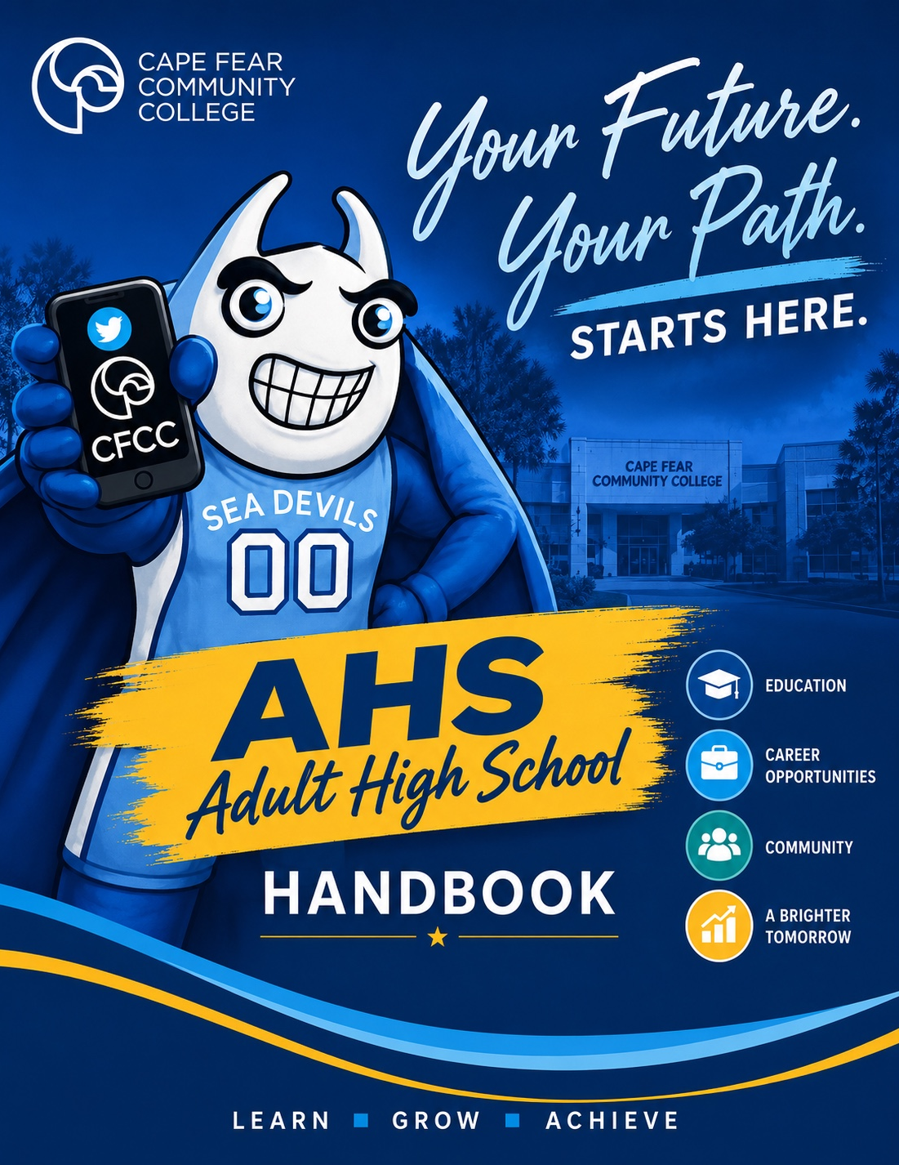
Welcome to Adult High School
YOUR FUTURE. YOUR PATH. STARTS HERE.
Welcome from the AHS Team
Welcome to Cape Fear Community College Adult High School. We are honored to be part of your journey as you work toward earning your high school diploma and preparing for what comes next.
Adult High School is more than completing credits. It is an opportunity to learn, grow, build confidence, explore career pathways, and prepare for college, the workforce, military service, and meaningful involvement in your community.
Our team is committed to providing personalized, high-quality instruction in a supportive learning environment. We believe in high expectations, strong relationships, student responsibility, and multiple opportunities to demonstrate learning. Throughout your time with us, you will have instructors and staff who are ready to guide you, challenge you, and help you move forward.
As you begin, we encourage you to attend consistently, communicate with your instructors, ask questions, use the resources available to you, and take ownership of your progress. Every course you complete brings you one step closer to graduation and to the future you are building.


We are proud to welcome you to AHS. This is your opportunity to begin strong, stay focused, and finish with purpose.

AHS Overview
PERSONALIZED • ENGAGING • CONNECTED • WORKFORCE READY
Mission Statement
Our mission is to provide the highest quality educational experience through personalized learning that fosters a culture of engagement. We are committed to promoting academic achievement, personal growth, workforce development, and meaningful community involvement. Through this foundation, students are equipped to continue their education, enter the workforce with confidence, and/or pursue service in the military, prepared to contribute positively to their communities and society.

Key Objectives
› | Deliver Personalized, High-Quality Instruction  Provide individualized learning experiences that promote engagement, academic excellence, and lifelong learning for every student.

› | Prepare Students for College, Career, and Military Pathways  Integrate workforce development, career readiness, and postsecondary planning so students graduate equipped to pursue higher education, meaningful employment, and/or military service.

› | Foster Personal Growth and Community Engagement  Cultivate character, responsibility, and civic involvement by encouraging students to develop leadership skills, positive relationships, and a commitment to serving their communities.

Adult High School at a Glance
MORE THAN A DIPLOMA
NC HIGH SCHOOL DIPLOMA  Complete the credits needed to earn a North Carolina high school diploma. Prior high school credits may count toward completion. | SMALL, SUPPORTIVE CLASSES  Face-to-face classes are designed for personalized support, meaningful feedback, and active student engagement.
FLEXIBLE LEARNING OPTIONS  Students may have access to face-to-face and online coursework based on program requirements, course availability, and readiness for the learning format. | CAREER PATHWAYS & IETs  Integrated Education and Training opportunities connect diploma completion with career preparation, workforce training, and industry-recognized credentials.
WORKFORCE READINESS  Courses incorporate communication, problem-solving, teamwork, professionalism, career exploration, and real-world learning experiences. | HONORS & ACHIEVEMENT  Students may graduate with honors by earning a 3.0 GPA and/or completing an industry-recognized credential through an IET pathway or class.
PROJECT-BASED LEARNING  Students have multiple ways to demonstrate learning through coursework, projects, presentations, hands-on activities, and other meaningful assessments. | SUPPORT FOR YOUR NEXT STEP  AHS staff help students prepare for transition to college, career training, employment, military service, and other postsecondary goals.

LEARN • GROW • ACHIEVE

English Courses
READ • WRITE • COMMUNICATE • THINK CRITICALLY
English I – Survey of Literature
Introduces students to a broad range of literary genres, including fiction, nonfiction, poetry, and drama. Students strengthen reading comprehension, writing, vocabulary, grammar, and discussion skills while learning how authors develop ideas, characters, themes, and meaning.

English II – World Literature
Explores literature and perspectives from cultures and regions around the world. Students analyze texts in their historical and cultural contexts while strengthening writing, research, communication, and critical-thinking skills.

English III – American Literature
Examines major works, voices, themes, and movements in American literature. Students connect literature to the historical and cultural development of the United States while practicing literary analysis, research, argument writing, and effective communication.

English IV – British Literature
Surveys significant works and traditions in British literature from early texts through more modern voices. Students analyze how language, culture, history, and literary movements shape texts while developing advanced reading, writing, research, and presentation skills.

Multicourse English
Provides a combined English learning experience for students who need coursework across more than one English level. Instruction is individualized around the specific English credit requirements a student still needs and may integrate literature, writing, research, communication, and project-based learning from multiple English courses.

Social Studies Courses
HISTORY • CIVICS • ECONOMICS • GLOBAL PERSPECTIVES
Civic Literacy
Introduces the foundations of American government, citizenship, constitutional principles, and civic participation. Students examine how government works, analyze current and historical civic issues, and build the knowledge needed to participate responsibly in their communities.

American History
Examines major events, people, movements, and ideas that shaped the United States. Students analyze historical sources and multiple perspectives while connecting the past to contemporary issues and developing evidence-based explanations and arguments.

Economics & Personal Finance
Connects basic economic concepts with practical financial decision-making. Students explore topics such as markets, employment, budgeting, banking, credit, taxes, saving, investing, and financial planning to build skills for adult life and the workplace.

World History
Explores major civilizations, events, ideas, conflicts, and global developments across time. Students examine connections among societies and cultures while using historical evidence to understand how the past continues to influence the modern world.

Mathematics Courses
PROBLEM-SOLVING • REASONING • APPLICATION
Math I
Builds foundational algebraic and mathematical reasoning skills through equations, functions, statistics, geometry, and real-world problem solving. Students learn to represent relationships in multiple ways and apply mathematics to practical situations.

Math II
Extends concepts from Math I through quadratic relationships, geometry, probability, and more complex functions. Students strengthen reasoning and problem-solving skills by connecting algebraic, graphical, and geometric representations.

Math III
Develops advanced algebraic and functional thinking, including polynomial, exponential, logarithmic, and other mathematical relationships. Students apply concepts to modeling, data, and real-world problems while preparing for college, career, and additional mathematics.

Math IV
Builds on prior high school mathematics with an emphasis on quantitative reasoning, functions, modeling, statistics, and applications. The course helps students strengthen mathematical skills needed for postsecondary education, careers, and informed decision-making.

Foundations of Math
Provides targeted support in essential mathematical skills needed for success in high school coursework. Students strengthen number sense, computation, algebraic thinking, problem-solving, and confidence through guided practice and practical applications.

Science & Health/PE
INVESTIGATE • APPLY • BUILD HEALTHY HABITS
Earth Science
Explores Earth’s systems and processes, including geology, weather and climate, oceans, natural resources, and Earth’s place in space. Students use scientific evidence, models, data, and investigation to understand changes in the natural world and their impact on people and communities.

Biology
Examines living organisms and the processes that support life, including cells, genetics, evolution, ecology, and biological systems. Students use scientific inquiry and evidence to explain relationships among organisms and connect biological concepts to health, the environment, and everyday life.

Physical Science
Introduces foundational concepts in chemistry and physics, including matter, energy, forces, motion, and interactions. Students use observations, calculations, models, and investigations to explain physical phenomena and connect scientific principles to technology, careers, and daily life.

Health/Physical Education
Supports students in developing knowledge and habits that contribute to lifelong health and wellness. Topics may include physical activity, nutrition, personal health, stress management, safety, and responsible decision-making, with opportunities to connect healthy choices to school, work, and everyday life.

YOUR INDIVIDUAL COURSE PLAN DEPENDS ON YOUR TRANSCRIPT AND REMAINING GRADUATION REQUIREMENTS.

Elective Course Descriptions
EXPLORE • DISCOVER • BUILD SKILLS
Elective courses allow AHS students to explore interests, strengthen workforce-readiness skills, and connect academic learning to careers and real-world experiences.
Fundamentals of Construction
Introduces foundational construction concepts, tools, safety practices, and employability skills through hands-on and career-connected learning. Students earn OSHA-10 and a pre-apprenticeship credential while developing practical skills that support further training, apprenticeships, and employment in the construction industry.

Introduction to Criminology
Introduces the study of crime, criminal behavior, and the ways society responds to crime. Students examine theories of crime, patterns of criminal behavior, and the roles of communities and institutions in prevention and response.

Introduction to Veterinary Science
Explores animal health, care, behavior, safety, and careers in veterinary and animal-related fields. Students develop an understanding of responsible animal care while connecting scientific concepts to real-world veterinary settings.

Sociology
Examines how individuals, groups, cultures, and institutions interact within society. Students explore topics such as socialization, culture, inequality, relationships, and social change while connecting sociological concepts to everyday life.

Criminal Justice
Introduces the major components of the criminal justice system, including law enforcement, courts, and corrections. Students explore careers, legal processes, ethics, and the responsibilities of professionals working within the justice system.

Elective Course Descriptions
CAREER • SERVICE • HUMAN DEVELOPMENT
Elective courses allow AHS students to explore interests, strengthen workforce-readiness skills, and connect academic learning to careers and real-world experiences.
Early Childhood
Introduces child development, learning, safety, and the responsibilities of professionals who work with young children. Students explore early childhood careers and examine practices that support healthy development and positive learning environments.

Emergency Medical Responder
Introduces foundational emergency response concepts, patient assessment, safety, and basic care in urgent situations. Students explore the responsibilities of emergency responders while developing awareness of communication, teamwork, and decision-making in emergency settings.

Psychology
Introduces the study of human behavior and mental processes. Students explore topics such as development, learning, memory, motivation, personality, and social behavior while applying psychological concepts to everyday experiences.

Visual Art I & II
Visual Art I introduces foundational art concepts, techniques, creative processes, and visual communication through a variety of media. Visual Art II builds on those skills through more advanced projects, artistic decision-making, critique, and the development of an individual creative voice.

Career Exploration
Helps students identify interests, strengths, values, and career possibilities while learning how education and training connect to future goals. Students research career pathways, develop employability skills, and begin building a practical plan for college, training, military service, or employment.

Elective Course Descriptions
TECHNOLOGY • BUSINESS • SKILLED TRADES
Elective courses allow AHS students to explore interests, strengthen workforce-readiness skills, and connect academic learning to careers and real-world experiences.
Cybersecurity
Introduces cybersecurity concepts, digital safety, networks, threats, and strategies used to protect information and technology systems. Students explore cybersecurity careers while developing technical awareness, problem-solving skills, and responsible digital practices.

Entrepreneurship
Introduces the process of developing, launching, and managing a business or entrepreneurial idea. Students explore opportunity recognition, customers, marketing, finances, business planning, and the skills needed to turn ideas into viable ventures.

Introduction to Trades
Provides exposure to skilled-trades careers through hands-on activities, workplace safety, career exploration, and practical projects. Students learn about trade pathways and develop foundational employability skills such as teamwork, problem solving, communication, and professionalism.

Food, Nutrition & Wellness
Explores nutrition, food choices, meal planning, food safety, and habits that support personal wellness. Students connect healthy decision-making to everyday life while building practical knowledge that can be used at home, in the workplace, and in food-related career fields.

Sports & Entertainment Marketing
Introduces marketing concepts through the sports and entertainment industries. Students explore branding, promotion, consumer behavior, sponsorships, events, and career opportunities while applying marketing strategies to real-world examples.

Adult High School vs. High School Equivalency (GED®)
TWO PATHWAYS. ONE GOAL: MOVING FORWARD.
Both programs offer classes, instructor support, and academic preparation, but students complete the programs differently. The best pathway depends on previous high school credits, learning preferences, academic readiness, testing ability, and future goals.
 | Adult High School (AHS) | High School Equivalency (GED®)
How it works | Students take classes and earn high school credits toward graduation requirements. | Students attend preparation classes and work toward passing four GED® subject-area tests.
What you earn | NC High School Diploma | High School Equivalency Diploma
Academic areas | Students complete the specific 22 credit-bearing courses they still need to meet NC graduation requirements. | Students prepare for testing in Mathematical Reasoning, Reasoning Through Language Arts, Science, and Social Studies.
Classes & instruction | Differentiated instruction, assignments, projects, assessments, and teacher support. Successful completion of each course earns high school credit. | Instruction and teacher support in all content areas prepare students for the four GED® tests. Students may progress at an individualized pace.
Completion | Students successfully complete their remaining required courses and credits to earn an NC High School Diploma. | Students must successfully pass all four GED® subject tests to earn a High School Equivalency Diploma.
Previous credits | Eligible credits previously earned may transfer and count toward the diploma, reducing the number of courses needed. | Previous high school credits do not reduce the four GED® subject tests required.
Potential time | Depends on the number of credits remaining and successful completion of required courses. | Academically prepared students and strong test takers may be able to complete more quickly.
Good fit for | Students who benefit from multiple ways to demonstrate learning through coursework, projects, and assessments. | Students who demonstrate strong academic readiness, are comfortable with standardized testing, and want a testing-based pathway.


Our Partner School Districts
A COLLABORATIVE PATHWAY TO HIGH SCHOOL COMPLETION
Cape Fear Community College Adult High School is offered through affiliation partnerships with New Hanover County Schools and Pender County Schools.
NEW HANOVER COUNTY  SCHOOLS | PENDER COUNTY  SCHOOLS

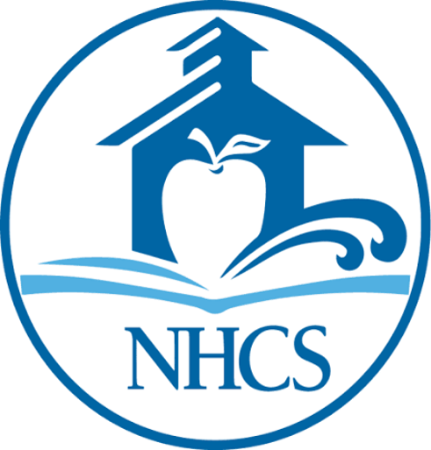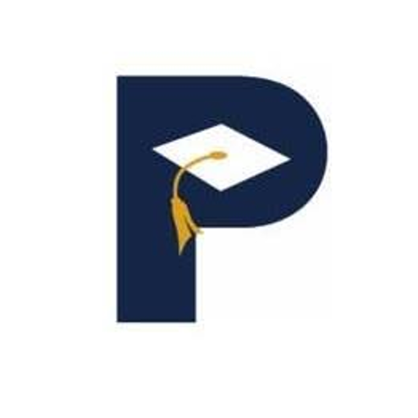

IMPORTANT CREDIT TRANSFER INFORMATION
Credits earned through the Adult High School program may not transfer back to a student’s local school district. Students considering a return to their local high school should speak with AHS staff and their school district before making enrollment decisions.

AHS Class Locations
MULTIPLE LOCATIONS. FLEXIBLE OPTIONS. ONE AHS COMMUNITY.
Downtown Wilmington Campus  Classes are Monday - Thursday  1:00-5:00 p.m. and 5:30-9:30 p.m. | North Campus (Castle Hayne)  Classes are Monday - Thursday  1:00-5:00 p.m. and 5:30-9:30 p.m.
Burgaw Center Campus  Classes are Monday - Thursday  5:30-9:30 p.m. | Surf City Campus  Classes are Monday - Thursday  1:00-5:00 p.m. and 5:30-9:30 p.m.

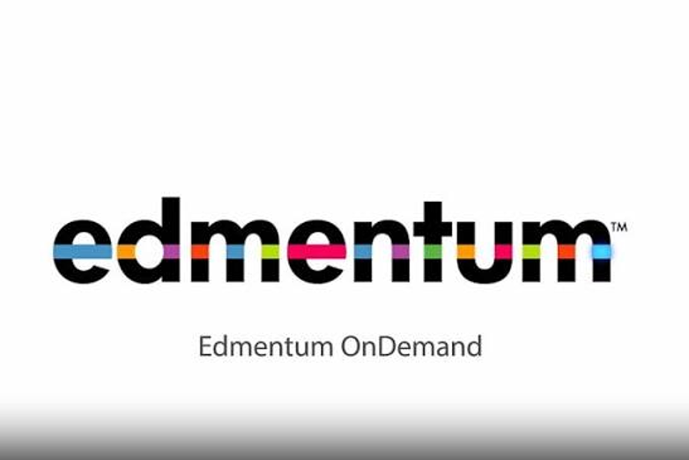

ONLINE LEARNING THROUGH EDMENTUM
Asynchronous online classes are available.

Class offerings and availability may vary by session.

The Adult High School Experience
MORE THAN CREDIT COMPLETION
Adult High School connects academic learning with career preparation, real-world experiences, leadership, and opportunities for students to plan their next step.
Career Pathways  AHS offers career pathways designed to move students from exposure to opportunity through a purposeful progression. Students explore careers while completing the academic requirements for graduation. | Project-Based Learning & Portfolios  AHS students participate in project-based learning that connects course content to authentic tasks. Students also develop portfolios in English and workforce development courses to document learning, skills, and accomplishments.
Workforce Development  AHS connects students with workforce preparation through local employers, industry partners, apprenticeships, work-based learning, internships, industry credentials, mentorship, and employment opportunities. | Student Leadership  Students may participate in the AHS Student Ambassador program. Ambassadors represent AHS, assist with tours and events, provide student perspective, and help strengthen the AHS community.



Strong partnerships create a network of support that enhances access, retention, completion, credential attainment, and employment outcomes for adult learners.

Creating Pathways
FROM EXPOSURE TO THE NEXT STEP
1 | Exposure — Career exposure begins across AHS classes and through program activities such as showcase events and career-connected learning.

2 | Exploration — Students participate in Career Exploration and work with Career Services and the AHS transition advisor to identify interests, strengths, and possible pathways.

3 | Experience — Students build experience through portfolios, community projects, internships, apprenticeships, job shadowing, and other work-based learning opportunities.

4 | Enrolled — Students may transition into IET pathways, Economic & Workforce Development classes, CFCC curriculum programs, or four-year college opportunities.

5 | Employed — Community partners, CFCC Career Services, and employment-focused activities help students connect their skills and training to meaningful employment.

6 | Enlisted — Students interested in military service can explore branches of the military as a postsecondary pathway.

EXPOSURE → EXPLORATION → EXPERIENCE → ENROLLED • EMPLOYED • ENLISTED

Student Support
GUIDING EVERY LEARNER WITH ENCOURAGEMENT, ACCOUNTABILITY, AND RESOURCES TO SUCCEED.
AHS students receive structured academic support designed to help them remain engaged, address challenges early, and make steady progress toward course completion and graduation.
Bi-weekly Check-ins  Students participate in bi-weekly check-ins to review progress and identify areas of need. During these meetings, staff work with students to develop a personalized learning plan to help them stay on track toward completion. | Progress Monitoring  Student progress is monitored regularly to support accountability and timely completion of coursework. Two reminder emails are sent prior to upcoming due dates to help students plan effectively and remain on schedule. | Academic Probation  Students placed on academic probation do not earn course credit during this period. This time is designed to help students refocus, address challenges, and rebuild the habits necessary for academic success.



SUPPORT + ACCOUNTABILITY + CONSISTENT PROGRESS

Attendance FAQs
ATTENDANCE IS ESSENTIAL TO EARNING COURSE CREDIT
1. How many hours do I need to attend to receive credit for a class?
Students need a minimum of 64 hours to earn credit for a class.

2. What happens if I don't meet the 64-hour minimum?
If a student does not earn at least 64 hours, the student will need to retake the class to earn credit. The only exception is an approved excused absence supported by a qualifying doctor's note.

3. Who should receive my doctor's note?
The student should submit the doctor's note to the Adult High School office to Mr. Lewis or Mrs. Winstead.

4. What is considered an excused absence?
An excused absence is an absence due to a communicable disease, such as COVID, strep throat, flu, or mono, that prevents the student from attending class. A doctor's note confirming the communicable disease is required.

5. What is a communicable disease?
A communicable disease is an illness caused by infectious agents, such as bacteria, viruses, fungi, or parasites, that can spread from one person to another, directly or indirectly. These diseases are also referred to as contagious or infectious diseases.

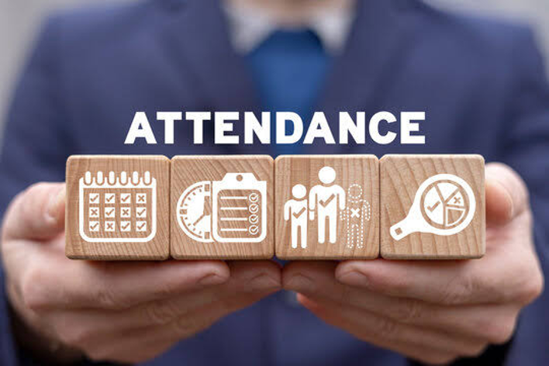

Attendance FAQs
EXCUSED ABSENCES & DOCTOR'S NOTES
6. Are there any other doctor's notes accepted for an excused absence?
No. Doctor's notes for other circumstances are not accepted as an excused absence under this attendance policy.

7. What does the doctor's note need to say for the absence to be excused?
The note must include: the student's name; date of visit or evaluation; confirmation that the student was diagnosed with or treated for a communicable disease; the dates the student was medically advised to stay home and the return date; and the medical provider's signature and contact information, including the practice name and phone number. A note will not be accepted if it only states that the student was seen in the office, omits the required stay-home dates, or is missing provider information.

8. If I have an excused absence, do I still get an additional four hours unexcused?
No. If a student has an excused absence, the student does not receive an additional four hours of unexcused time.

9. What happens if I have already missed one day (or docked time) unexcused, then get sick and bring a doctor's note for a communicable disease?
The student must provide a doctor's note containing the required information to avoid being timed out of the class. However, the student cannot miss additional time, including the last night of class, and must remain for the entire class period needed to earn credit.



Attendance FAQs
MAKE-UP WORK, ONLINE ATTENDANCE & QUESTIONS
10. Can I make up hours for an absence?
No. Students are not allowed to make up attendance hours for an absence.

11. Are students expected to make up work for an excused absence?
Yes. Students are expected to make up all work for an excused absence within one week.

12. Do online students have attendance requirements?
Yes. Online students must meet the same 64-hour attendance requirement. Online students can never be more than four hours behind the weekly required hours at the weekly check-in deadline.

13. Who should I contact if I have additional questions about attendance and/or a doctor's note?
Students should contact the Adult High School team about attendance questions. Mr. Lewis: rmlewis164@mail.cfcc.edu | 910-362-7348. Mrs. Winstead: adwinstead184@mail.cfcc.edu | 910-362-7290. Please do not ask your instructor to determine whether an absence is excused. Only the Adult High School team can advise students about attendance and approve attendance-related documentation.

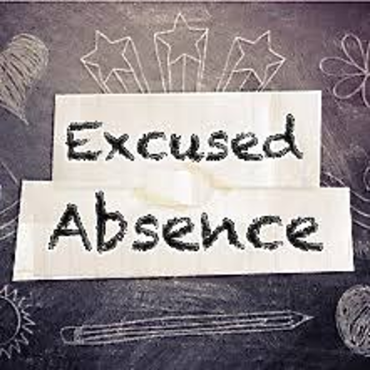

64 HOURS MINIMUM • ATTENDANCE HOURS CANNOT BE MADE UP • CONTACT THE AHS TEAM WITH QUESTIONS

Choose the Learning Option That Works for You
FACE-TO-FACE • ONLINE • COMBINATION
Adult High School offers flexible learning options so students can build a schedule that supports their academic goals. Depending on course availability and student readiness, students may attend face-to-face classes, complete online coursework, or use a combination of both.
FACE-TO-FACE  Learn in a classroom with direct instructor support, structured class meetings, collaborative activities, projects, and opportunities for immediate feedback. | ONLINE  Complete asynchronous coursework through Edmentum. Online learning provides flexibility while still requiring consistent weekly progress, attendance hours, communication, and completion of assigned coursework. | COMBINATION  Build a blended schedule using both face-to-face and online classes. This option can provide the structure of classroom instruction along with the flexibility of online coursework.

NEW TO ONLINE LEARNING?
Students who are new to online learning must attend a virtual orientation before beginning their online classes.
During Virtual Orientation, Students Will:
Best Practices for Online Success  Review expectations for time management, communication, consistent progress, and successful online learning habits. | Experience Edmentum  Tour the Edmentum platform so students know how to navigate courses, locate assignments, monitor progress, and access course resources.
Understand Pacing Guides  Learn how to use pacing guides to stay on schedule and meet weekly course and attendance expectations. | Use Guided Notes  See how guided notes support learning, organization, studying, and completion of online lessons.

The goal of orientation is to make sure students understand the platform and have the tools to begin online learning successfully.

Edmentum Sample Letter & Pacing Guide
ONLINE COURSE EXPECTATIONS
Students enrolled in Edmentum receive course information that includes login directions, course expectations, and a pacing guide. Use the pacing guide to monitor weekly attendance hours and stay on track for successful course completion.
Course Expectations
Plan to work at least 8 hours per week, per course. To be eligible to earn credit, students must:
1. Complete at least 80% of the coursework.
2. Actively participate for a minimum of 64 of the 68 scheduled hours.
3. Earn a minimum grade of 60%.
Edmentum Login
Log in at auth.edmentum.com/elf/login. Avoid using a cellphone when possible.
Account: CFCC | Login: provided to student | Password: provided to student
Sample Weekly Pacing Guide
Attendance Checkpoint | Hours Required | Minimum Hours  (includes 4-hour allowance)
Week 1 | 4 hours | —
Week 2 | 8 hours | 4 hours
Week 3 | 16 hours | 12 hours
Week 4 | 24 hours | 20 hours
Week 5 | 32 hours | 28 hours
Week 6 | 40 hours | 36 hours
Week 7 | 48 hours | 44 hours
Week 8 | 56 hours | 52 hours
Final | 68 hours | 64 hours

The exact dates on each student's pacing guide will vary by session. Students should follow the deadlines provided in their individual Edmentum letter and contact the AHS team with questions.

Student Assessment
CASAS ASSESSMENT • PLACEMENT • PROGRESS • PERSONALIZED INSTRUCTION
Assessment is an important part of the Adult High School experience. We use CASAS assessments to better understand each student's academic skills, measure progress, and provide instructors with information that supports differentiated instruction.
Initial Assessment  Students initially enrolling in the AHS program complete CASAS assessments in Reading and Math. Results help establish an academic starting point and identify areas where additional support may be helpful. | Ongoing Assessment  Students are reassessed approximately every 40 instructional hours. These checkpoints help document growth and provide updated information about student progress. | Instructional Support  Assessment results are used as instructional information—not simply as a score. Instructors can use the results to identify strengths, target skill gaps, and differentiate instruction to better meet student needs.



WHY ASSESS?
North Carolina uses approved adult education assessments to determine placement, communicate progress, guide personalized instruction, and document measurable skill gains.
ASSESSMENT HELPS US SEE WHERE YOU ARE, RECOGNIZE YOUR GROWTH, AND PLAN WHAT COMES NEXT.

Integrated Education & Training (IET)
EARN YOUR DIPLOMA WHILE BUILDING CAREER SKILLS
IET pathways give eligible AHS students the opportunity to work toward high school completion while participating in career and technical training. Students may finish with both their high school credential and a certificate or industry-recognized credential in a career field.
Construction | Nurse Aide Level 1
Culinary Fundamentals | Medical Admin Assistant
Facility Maintenance Tech | Dog Grooming
Google Cybersecurity | Truck Driver Training
HVAC | Welding
Nail Tech | Floor Installation



Important to Know
Eligibility is determined by several factors. Tuition may be waived for eligible students, although some additional fees may apply. Program length, schedule, and format vary by pathway.

AHS Honors
ACHIEVE. EARN. CELEBRATE.
AHS Honors recognizes students who go above and beyond to demonstrate academic excellence and career readiness.
ACADEMIC ACHIEVEMENT  Earn a GPA of 3.0 or higher in AHS coursework. | CAREER ACHIEVEMENT  Earn an industry-recognized credential through an IET pathway or AHS course.

Meeting either option makes a student eligible for AHS Honors.
Students Will Receive
AHS Honors Cord  Wear an AHS Honors cord at graduation as a symbol of hard work and achievement. | AHS Honors Certificate  Receive an AHS Honors certificate recognizing your accomplishment.

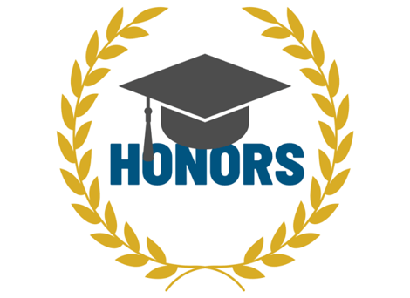

YOUR FUTURE. YOUR CHOICE. YOUR HONORS.
Stay focused. Keep pushing. Finish strong.

Student Leadership
REPRESENT AHS. WELCOME OTHERS. MAKE A POSITIVE IMPACT.
The AHS Student Ambassador program gives students an opportunity to become more involved in the Adult High School community while developing leadership, communication, and service skills.
Represent the AHS Program — Serve as a positive student voice and help showcase the Adult High School experience.

Welcome New Students — Help new students feel connected and supported as they begin their AHS journey.

Give Campus Tours — Assist with tours, orientations, events, and other opportunities to introduce students and guests to AHS.

Make a Positive Impact — Model professionalism, responsibility, encouragement, and commitment to the AHS community.

Mentorship Opportunities — Build leadership experience by supporting peers and participating in program activities.

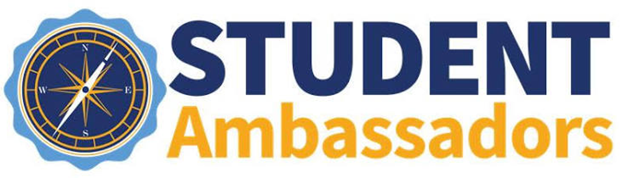
Interested in becoming an AHS Ambassador? Ask the AHS team how to get involved.

Free CFCC Student Resources
ACADEMIC • PERSONAL • FAMILY • BASIC NEEDS • CAREER SUPPORT
CFCC offers resources designed to help students overcome barriers, stay focused on their education, and move toward graduation and their next step.
Tutoring
Free tutoring is available through the Learning Lab. Downtown: L-220. North Campus: NA-113. Online tutoring is also available through Tutor.com. Writing and math support schedules may vary by semester.

Counseling & Student Support
Students can access academic and personal support. Additional assistance may include bus passes and loaner laptops based on availability and eligibility.

Drop-in Child Care
Drop-in child care is available for children ages 6 months and older. Students should review current operating hours, eligibility, registration requirements, and the four-hour-per-day limit before using the service.

CFCC Food Pantry
Students experiencing food insecurity may access CFCC food pantry resources for additional support. Contact the college or AHS team for current pantry locations, hours, and access information.

Dress for Success Closet
AHS and Academic & Career Readiness students may access professional clothing through the Dress for Success closet. Clothing can support interviews, employment, presentations, career events, and other professional opportunities. Available by appointment.

Student Accessibility Services (SAS)
Student Accessibility Services provides support for students with disabilities and works with the college to help ensure programs, facilities, and activities are accessible. Students who may need accommodations or accessibility support are encouraged to contact SAS for a confidential discussion.
Email: sas@cfcc.edu | Phone: 910-362-7017
NEED HELP CONNECTING TO A RESOURCE?
Talk with the AHS team. Asking for support is part of building a successful path toward completion.

Transition Advising
YOUR NEXT STEP STARTS BEFORE GRADUATION
Transition advising helps AHS students plan for life after graduation and connect with the people, programs, and resources that can help them move forward.

Plan Your Next Step
Work directly with AHS/ACR staff to explore postsecondary options, apply to college or degree programs, navigate Continuing Education/Economic & Workforce Development opportunities, or prepare to enter the workforce.

Connect to Resources
Receive referrals and connections to CFCC and community resources, including the ACR Scholarship, Career Services, counseling, tutoring, housing and food assistance, and other student supports.

Build a Support Network
Transition advising may connect students with community partners and workforce programs such as StepUp and WIOA Title I specialists for employment, training, and financial-support resources.

Graduation & Beyond
Transition support continues as students approach graduation. AHS/HSE graduates can receive guidance on college enrollment, career training, career readiness, and workforce opportunities.

YOUR CAREER ADVISOR
Madison Gill | Career Advisor
Office: S 102 • Email: mtgill968@mail.cfcc.edu • Phone: 910-362-7987
GRADUATION IS A MILESTONE—NOT THE END OF THE PATH.
Your AHS team can help you identify and take your next step.

Career Readiness & Career Pathways
FROM SKILLS → CREDENTIALS → CAREER → LONG-TERM SUCCESS
Career readiness is built into the AHS experience so students can strengthen workplace skills, explore career fields, and connect learning to a sustainable next step.
CAREER READINESS SKILLS  • Career exploration & pathway planning  • Interview preparation & confidence  • Communication & professionalism  • Résumé writing & job-search strategies  • Computer & technology skills  • Workplace readiness and employability skills | PATHWAYS TO BUILD ON  Students can connect foundational skills to pathways in areas such as technology, skilled trades, healthcare support, hospitality, human services, public safety, digital/office skills, and Integrated Education & Training (IET).

Stackable Credentials
Some pathways are designed to build from one credential or training experience into the next. For example, a student may begin with Google Cybersecurity, continue into IT support training, and later pursue a Cybersecurity A.A.S. Each step can build skills and create momentum toward a college credential and career.

Who Can Benefit?
Career starters, students changing industries, veterans, and anyone who wants to strengthen workplace skills or prepare for a new opportunity. Career readiness opportunities may be available at multiple CFCC locations, online, and at selected community sites.



EXPLORE YOUR OPTIONS. BUILD YOUR SKILLS. TAKE THE NEXT STEP.

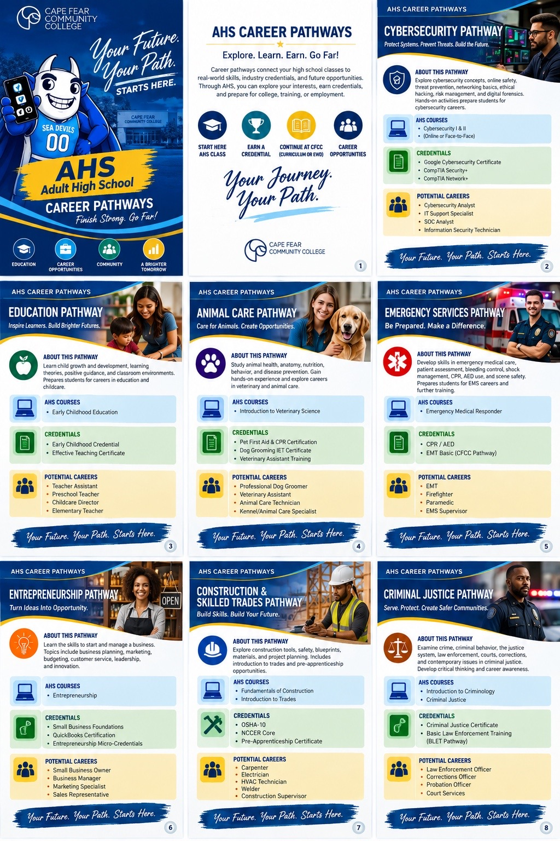
Beyond the Classroom
CONNECT • EXPLORE • EXPERIENCE • BELONG
The AHS experience extends beyond coursework. Students have opportunities to connect with the CFCC community, explore careers, gain real-world experience, and celebrate their progress along the way.
Showcase Night
AHS Showcase Night gives students an opportunity to explore programs, career pathways, student work, and resources available through CFCC and community partners. It is a chance to ask questions, make connections, and discover possibilities for the next step after graduation.

Field Trips
Field trips extend learning beyond the classroom by connecting students with employers, college programs, community organizations, and real-world environments. These experiences help students explore careers, see classroom learning in action, and learn more about opportunities available in the community.

Apprenticeship & Pre-Apprenticeship
Students may have opportunities to participate in pre-apprenticeship and apprenticeship-connected experiences that combine career preparation with hands-on learning and industry exposure. These opportunities can help students develop workplace skills, connect with employers, and build a pathway toward additional training or employment.

Student Appreciation Night
Student Appreciation Night celebrates the effort, progress, and accomplishments of AHS students while bringing the school community together. Students can connect with classmates and staff, enjoy recognition and activities, and celebrate the milestones they have achieved during their AHS journey.

CFCC Clubs & Campus Involvement
AHS students can participate in CFCC clubs and student organizations available to eligible students on campus. Getting involved provides opportunities to meet other students, develop leadership and teamwork skills, explore interests, and become more connected to the broader CFCC community.

YOUR AHS EXPERIENCE IS MORE THAN A CLASS SCHEDULE.

Celebrating AHS Students
RECOGNIZING PROGRESS • ACHIEVEMENT • LEADERSHIP • CAREER SUCCESS
At Adult High School, we celebrate more than graduation. Throughout the year, students may be recognized for their progress, accomplishments, perseverance, leadership, and success in academic and career pathways.
Student of the Month — Recognizes students who demonstrate strong effort, growth, attendance, engagement, responsibility, or a positive contribution to the AHS community.

AHS Student Highlights — Shares student stories, milestones, leadership, projects, and accomplishments that reflect the many ways AHS students are succeeding.

Academic Achievement — Celebrates meaningful academic progress, course success, strong performance, and students who demonstrate commitment to reaching their educational goals.

IET Spotlights — Highlights students participating in Integrated Education & Training pathways, including career training, hands-on experiences, and industry-recognized credential achievements.

Senior Spotlights — Recognizes students approaching graduation and gives them an opportunity to celebrate their AHS journey, accomplishments, and plans for what comes next.

Rising Strong Award — Recognizes students who demonstrate resilience by overcoming challenges, continuing to move forward, and showing determination and perseverance in their educational journey.
FEATURED IN THE AHS NEWSLETTER
Student recognition and spotlight features may be shared in the AHS newsletter to celebrate success and strengthen our school community.

Graduation
CELEBRATING YOUR ACHIEVEMENT
Completing Adult High School is an achievement worth celebrating. Students who meet all AHS graduation requirements are invited to participate in Cape Fear Community College's summer commencement ceremony.
Who Is Invited?
All eligible Adult High School and High School Equivalency graduates are invited to participate in CFCC's summer commencement ceremony.

When Is Commencement?
The ceremony is typically held in late July or early August.

When Will I Receive Details?
Graduation information and ceremony details are generally sent approximately one month before commencement.

What Happens After I Complete AHS?
The AHS team will confirm completion of graduation requirements. Students will also receive transition support to help plan their next step into college, career training, employment, or other postsecondary opportunities.

AHS HONORS GRADUATES
Students who qualify for AHS Honors may wear their AHS Honors cord at graduation and receive an AHS Honors certificate.

YOU DID THE WORK. YOU EARNED THE DIPLOMA. NOW CELEBRATE THE MILESTONE—and keep moving toward what comes next.

Our AHS Team
WORKING TOGETHER TO UPHOLD EXCELLENCE, ACCOUNTABILITY, AND OPPORTUNITY FOR EVERY LEARNER.
For questions regarding attendance, registration, class information, or your progress in Adult High School, please contact the AHS team. We are here to provide guidance, answer questions, and support you throughout your academic journey.
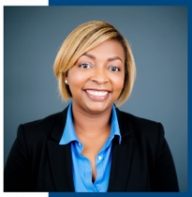 | Aja Winstead  Director, Adult High School & Career Pathways  Email: adwinstead184@mail.cfcc.edu  Phone: 910-362-7290
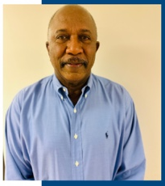 | Reginald Lewis  AHS Assessment Retention Specialist  Email: rmlewis164@mail.cfcc.edu  Phone: 910-362-7348

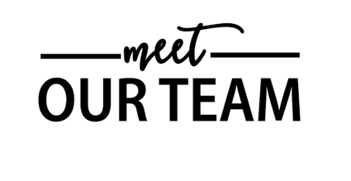

QUESTIONS? CONNECT WITH US.
The AHS team is committed to helping you stay informed, supported, and on track toward graduation.

